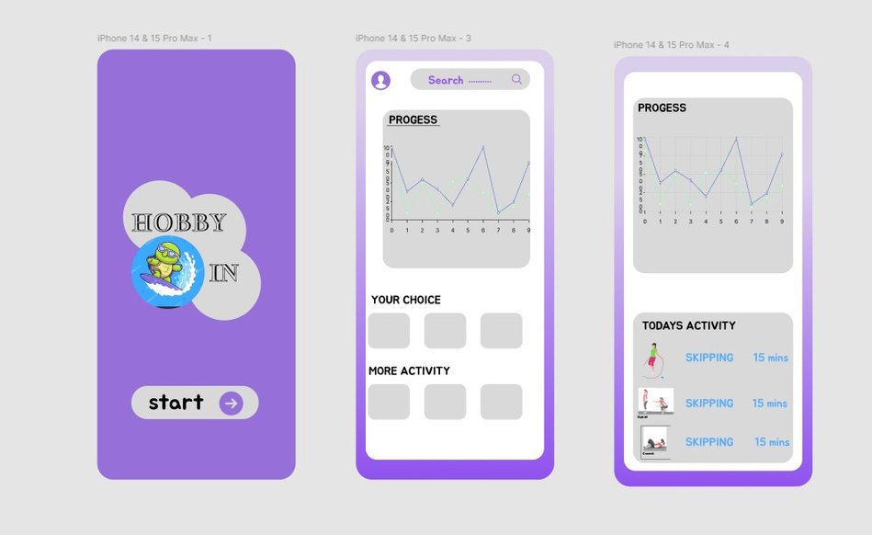

**hobby app**

**Aim:**   
To develop a simple app that helps users easily manage and track their hobbies.

**Procedure:**

1. **Identify Key Features:** Decide what features are essential for the hobby app (e.g., hobby tracking, scheduling, reminders, or progress logs).
2. **Choose a Platform:** Select whether to build the app for iOS, Android, or both.
3. **Design UI/UX:** Create a user-friendly interface with easy navigation and appealing visuals.
4. **Development:** Use app development tools (like Swift for iOS or Kotlin for Android) to build the app.
5. **Testing:** Test the app for bugs and user experience issues, and make improvements.
6. **Launch:** Release the app on the app store for users to download.

**Result:** A functional, user-friendly app that helps users manage their hobbies by tracking progress, setting reminders, and keeping records.